1) 1. Get me the IP address of a particular domain (guvi.in)

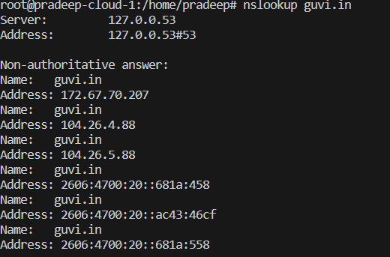

3. Test the connectivity between 2 nodes.

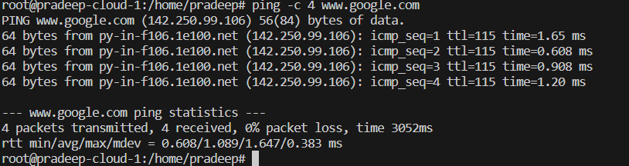

2. How do I find the CPU/memory usage of my server?

